YOUR NAME HERE
CIS ???
Lab ??
1. Write a script to say Wat up!

Code:
#!/bin/sh

echo "Wat up!"

Test run screenshot:
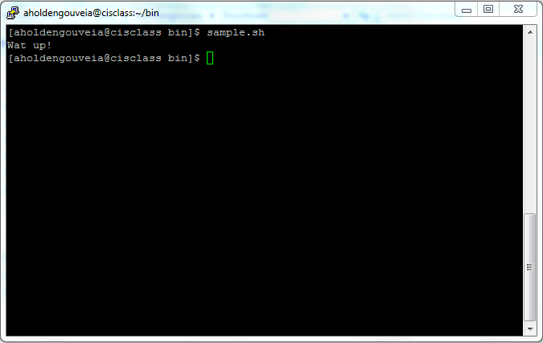

2.
Code:
Test run screenshot:

